API INTEGRATION

AND DATA MIGRATION

## MUSKAN BATOOL

### DAY-3 TASK

#### INTRODUCTION:

API integration helps different apps or systems work together by sharing data, like a food delivery app connecting with a restaurant’s system.

Data migration is moving information from one place to another, like transferring contacts from an old phone to a new one.

SCHEMA:

*CATEGORY SCHEMA:*

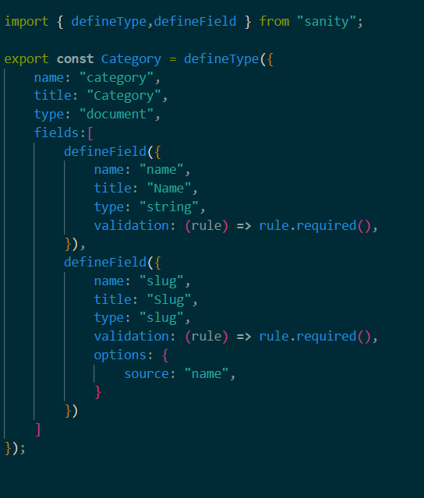

*PRODUCT SCHEMA*

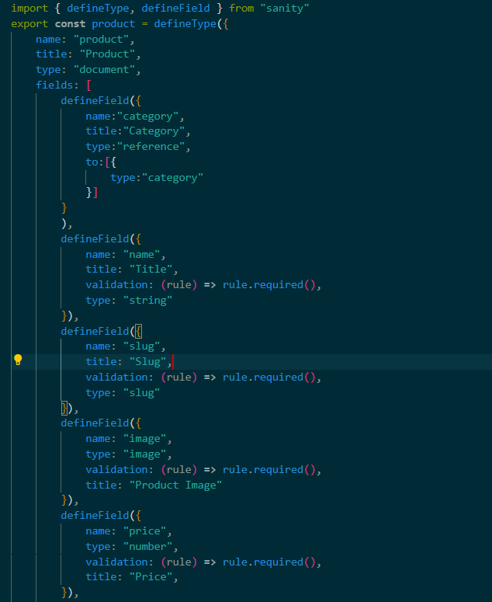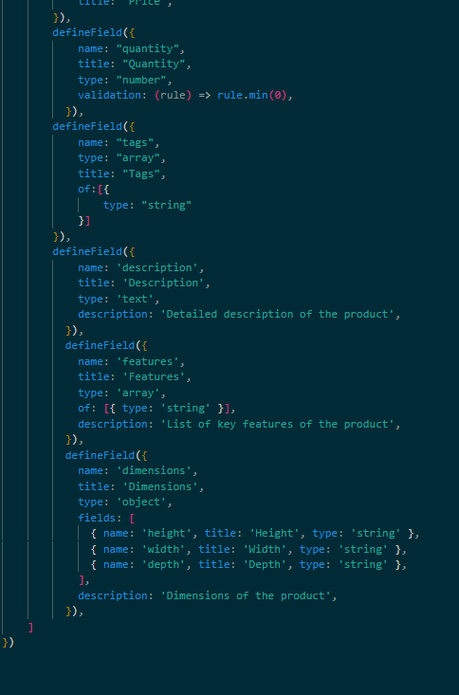

### API INTEGRATION

#### *API URL*



#### *ENDPOINTS*

#### *PRODUCTS: api/products*

#### *PRODUCT API*

